Company Summary:
Companion Data Services, LLC (CDS) provides leading IT solutions and managed services that power the highest levels of performance for the benefit of clients. We operate multiple geographically dispersed data centers, including two of the nation’s largest health care data centers, both rated among the top five percent of data centers worldwide by MIPS.

CDS’ decades of experience in the government, commercial and education markets, drive innovation, industry-standard security and reliability and efficiency, allowing our clients to focus on their core business to improve outcomes. Our scalable, client focused solutioning approach is trusted by customers in all 50 states as well as countries outside the U.S.

Challenge Summary:
Multiple relocations and growth on the IBM Z platform requiring deep archival of data using cloud based virtual tape solutions that could be simultaneous accessed from multiple data centers. The rapid growth of historical or older data made it impractical to continue storing on online and physical storage.

Solution Summary:
Companion Data Services, LLC (CDS) was able to expand their existing Luminex Channel Gateway X (CGX) to include a new datacenter with Luminex CloudTAPE connectivity. By moving all deep archival data to a cloud only storage, CDS was able to greatly reduce their physical and online storage footprint while still having immediate access to their archive data when necessary.

Results Summary:
- Migration of data to a cloud only storage reduced the online physical storage footprint
- Reduced on-site virtual tape storage footprint
- Flexible Cloud Storage retrieval options allowed for easy recall of data as needed

Challenge Story:
Luminex’s challenge was to resolve CDS’ needs for deep archival storage with minimal changes to their operations and recovery. Because the existing solution contained multiple PB’s of archival data, it was necessary that the archival storage target was flexible and could be accessed from multiple data centers. Doing a full data migration of this data for each storage upgrade or data center move would have been costly and time consuming. Additionally, because much of the data was archive data, it was necessary to have a storage solution that did not consume valuable local storage that would be costly to migrate.

Solution Story:
An analysis of CDS’ tape environment found that a large portion of tapes meant the requirements to be placed into an archive cloud storage target. For the data center migration, it was identified that that the archive data could exist as a cloud only copy, eliminating the need to physically migrate any of the data. This allowed the data to be accessible from multiple data centers and future proof’s the solution from any future physical online storage upgrades or migrations. Any archive data that is needed is easily retrieved directly from the cloud target.

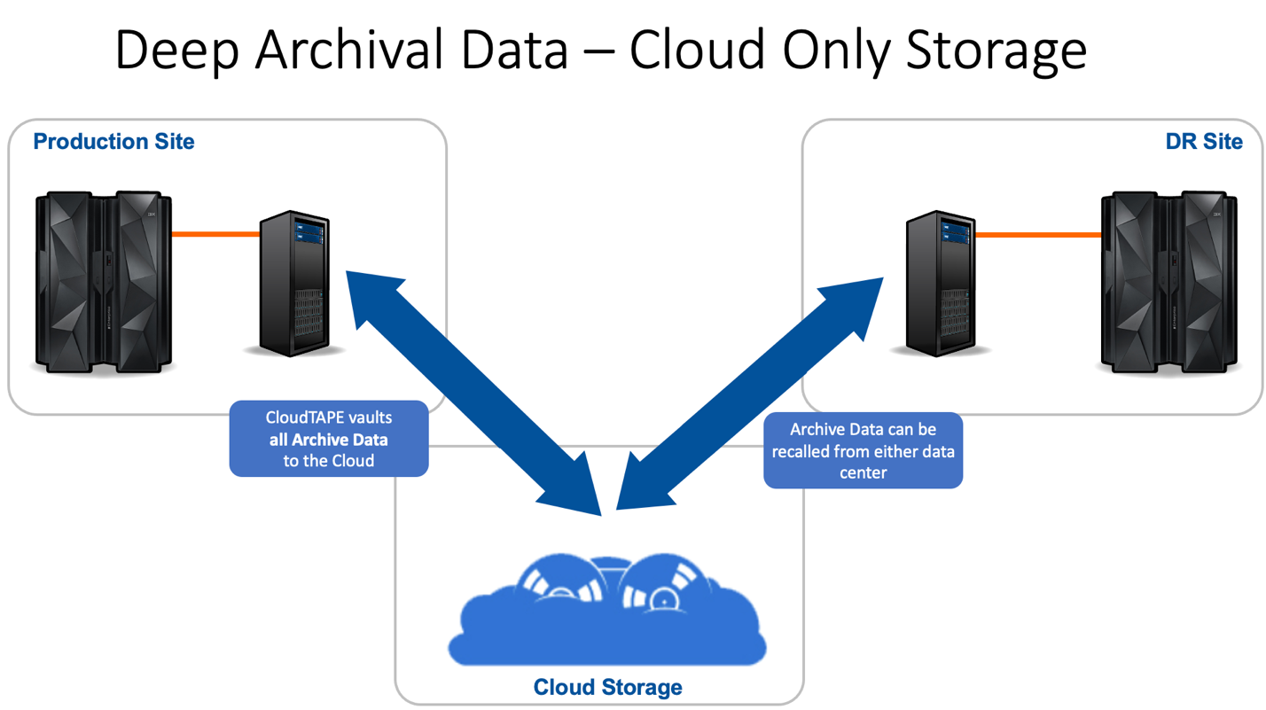

Results Story:
The Luminex CGX solution with CloudTAPE allowed CDS to store critical IBM Z platform archive data on a flexible cloud storage target. This hybrid cloud infrastructure allowed CDS to store their deep archival data in a location that would not require periodical migrations or moves. The result was a best fit cloud storage solution that optimized CDS’s operations and physical footprint ensuring that their archival storage operations were optimized and protected into the future.

